Welcome to the SFSC!
The Springfield Figure Skating Club (SFSC) is excited that your family has decided to become part of our figure skating family. We are celebrating over 40 years as a thriving club in Springfield, IL at the Nelson Center.
SFSC is an organization for recreational and competitive skaters of all ages. Members compete in Regional, Sectional, National and International Competitions. We also provide fun activities for all members and their families including exhibitions, holiday events, workshops, and fundraisers. We host an annual competition and put on Spotlight on Ice - central Illinois’s biggest ice show!
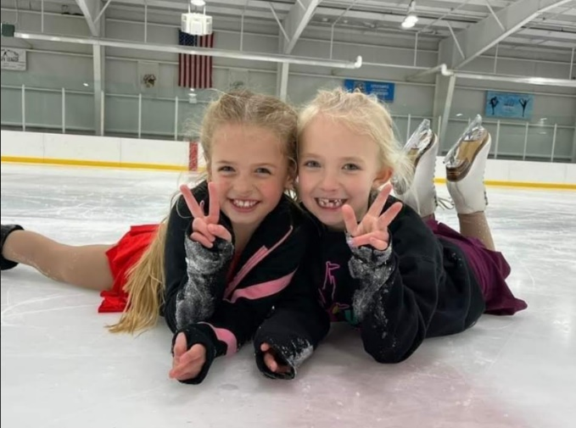
Membership period runs July 1st through June 30th each year.

What SFSC asks of its members…
- Volunteer 10 hours per family in club events and additional 10 hours minimum during Spotlight On Ice
- Complete FREE on-demand webinar for SafeSport training and pass background check
- Assist in fundraising

Membership Cost
All minors must join with an adult. There are membership options for US Figure Skating:
- Individual Skating (1 adult membership): $152
- Family Skating (1 adult & 1 under 18 membership): $192
- Intro Family Skating – first year of club membership (1 adult & 1 under 18): $160
- Additional Family (additional adult or child membership): $40
- Collegiate: $100
How to Join
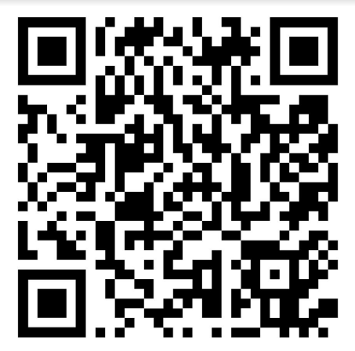
To join the club, go entryeeze.com. Choose Find your home club under Membership/Testing. Search for Springfield and you’ll see us! Or follow the QR code to sign up!

For more membership info, please reach out to rkhart1990@gmail.com or ai_mt@yahoo.com

